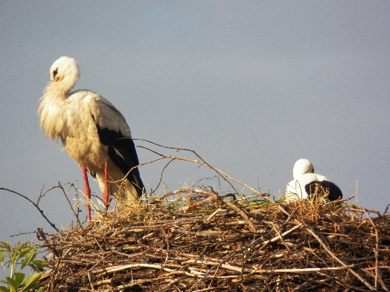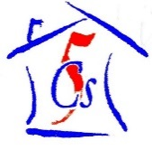

**The 5Cs Summer Report 2015**

Written by our Chair of Trustees and Volunteer Coordinator, Bethan Powell.

As we (eventually!) adjust to life back in the UK and get back to reality after another incredible summer in Zabrodia we wanted to let you, our fantastic support network, know what we have been up to!

Our two, very equal purposes in supporting the Hospice are firstly to fundraise money to help towards costs of its summer camp programme each year and raise awareness of its work in doing so. All fundraised money goes to the Hospice. Secondly to support the summer camp programme in the form of volunteers giving their own time and money to help run this camp each year.

I, for the second year, spent 11 weeks at the camp coordinating 5Cs and other foreign volunteers and was part of the team for every group. It is really such a unique experience to see the whole project from beginning to end, and gives us a very good overview of how we can help and support the Hospice more, as well as emphasise where we have worked hard and done things right too. So now it is time for me to reflect on the 11 weeks to update you all…wish me luck!

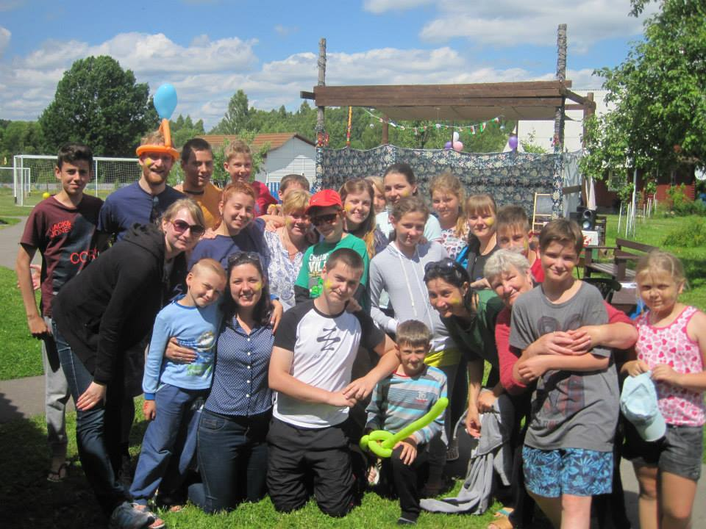This summer 30 volunteers from Wales ventured to The Belarusian Children’s Hospice summer camp in the beautiful little village of Zabrodia. The camp provides a much needed break for families and children under the care of the Hospice and is run by Hospice staff and a team of international volunteers. Our volunteers make up half of this international team for each session that care for children, prepare activities and help with all duties to keep the camp running smoothly. There are five sessions from mid-June to end of August.

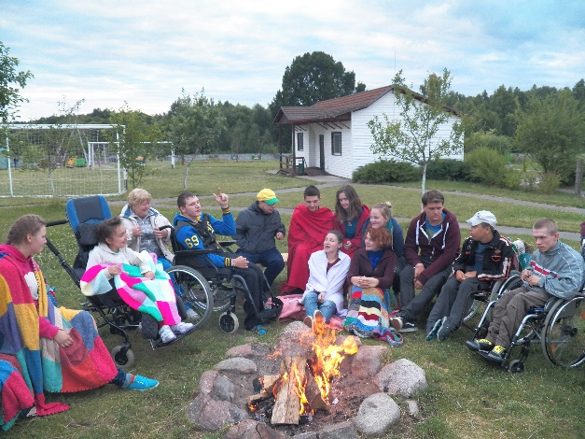I, along with other experienced volunteers, feel very strongly that it is important that we are all part of the team for new volunteers to learn by example and for them to feel they are not being asked to do anything that we would not do with them. It makes for a very happy camp and we will always, where we can, work in this way. After flying home with the last group on August 30th, I have now been back in the UK longer than I was at the summer camp, which is hard to believe! How time flies…

This summer marked an amazing 10 years of involvement at Zabrodia from The 5Cs. It was some of our current team’s ninth year of volunteering and for many more the seventh, sixth, fifth, fourth….years. It is no exaggeration to say that for many of us the summer camp is a second home and a place we cannot imagine not spending our summer’s at! We have even had new volunteers tell us that, if they can help it, they are never going 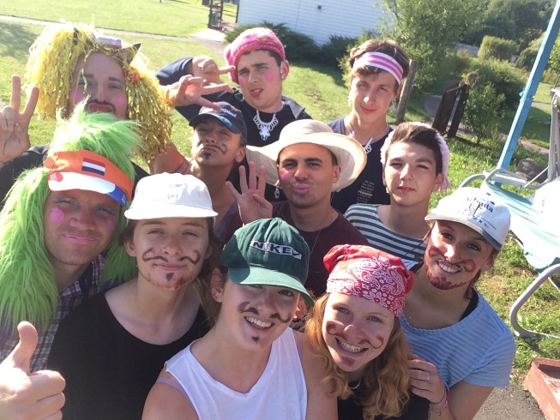to have a summer without being in Zabrodia again. It seems that the feeling is infectious and suggests a bright future for our project!

We were lucky to get some funding for our project from GwirVol in 2014 that meant we could employ a part time volunteer coordinator for a year, buy our own car in Minsk, make the project more accessible for more young people and many more things!

For the past nine years we have also taken a group of volunteers that have helped with maintenance work, however this year all our new recruits from various schools and existing volunteers wanting to return, all expressed that they wanted to volunteer with the children. The Hospice had employed a manager to help with maintenance work and so our group not going this year wasn’t going to cause any problems for the camp. Therefore for the first time since the project began, all our volunteers were childcare volunteers. This, we feel, is a fantastic outcome- engaging more and more of our new volunteers in particular (even the hard to find boys!) with the joy of volunteering with the children at the camp. It also meant that our experienced volunteers were even more integral to the project as they supported me in supporting the new volunteers within a much larger childcare group and the whole system ran like clockwork…well as much as it ever will in Zabrodia! We were able to share the workload much more, get much more sleep and generally help the manager, cook and families in the Stork Project more as a result of being a larger team- success!

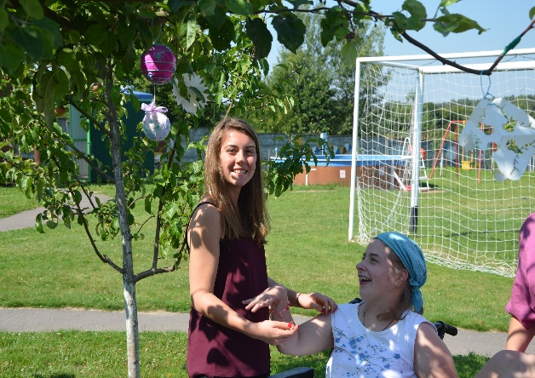It would be far from the truth to say that experience means we are ready for anything, every summer throws many challenges of course, as you would expect. This year we juggled visa delays, flight complications, wrong genders on passports (no joke!), a few minor accidents meaning far too many hours sitting in the local hospital, lost cooks (mushroom picking!), lost keys, broken hearts, allergies, illnesses and many more daily logistical problems as you can imagine when dealing with so many people over such a period of time.

However these problems melt away into insignificance and are replaced in our memories with many special moments and so many days that we will never forget. We had themed days including underwater, olympic, around the world, business, spa, talent show, super hero, pirate, eco, Christmas, even time travel! As well as the favourite National Days of the volunteers- Welsh, of course and Belarusian.

Some of the children that visit the camp need 24 hour care with many aspects of their lives, including showering, toileting and eating. All the volunteers do a brilliant job- adapting to their physically and mentally challenging role very quickly- many of them with no previous experience. Bearing in mind the 5Cs volunteers don’t speak Russian and not many of the children speak English, the way that they find creative ways of communicating and take everything in their stride never fails to amaze us. All of the 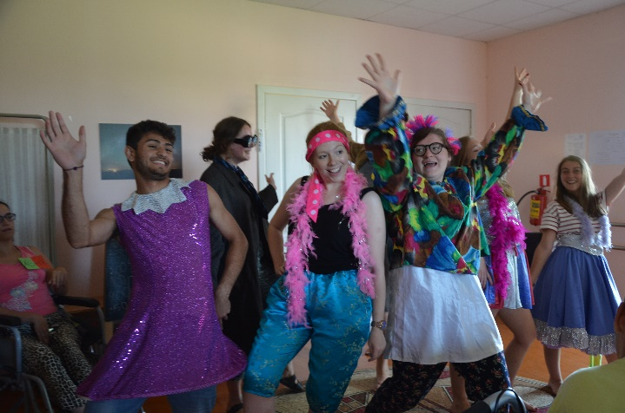groups were so close by the end that there were always the inevitable tears when the bus came to collect everyone to go home!

We dressed up, sang, danced and laughed together all summer. Every evening, once the children were tucked up safely in bed, the committed team of volunteers planned every detail of the next day to give the children a two week holiday packed full of fun and friendship. It really is a very special place. The experience that all the volunteers and children share together there is completely unexplainable to anyone who has not experienced it and ties us all together, like a large unconventional family!

This year we welcomed some experienced Belarusian volunteers into the role of volunteer coordinator for the first time this year, developing an experienced network that we can build on- they all did a fantastic job and also enjoyed it!

We also welcomed some incredible new volunteers from Belarus- (wonderfully, including the hard to reach boys once again!) volunteering for the first time. Again, they did such a brilliant job- growing our team in Belarus too, something we are investing a lot of time and effort in helping with.

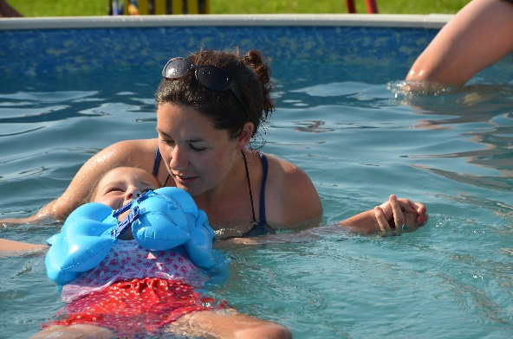We looked after over 60 children, saw many more families at the family house, cooks, nurses, managers, over 100 volunteers, volunteer coordinators, TV crews, radio presenters, ambassadors, business people, sponsors, clowns, scientists, astronomers…. the list could continue! We blew out countless birthday candles, ate so many potatoes and an unthinkable amount of Anna Nikolayevna’s Blinis, consumed more coffee than the local shop could replenish…not only me (honestly!)…. created so many costumes, dance routines and sketches…sang Welsh and Belarusian campfire songs hundreds of times…. and we are already busy preparing to do it all again next year!

We are so proud of what we have, and will continue to achieve in Zabrodia, but we could not do it without the amazing people that support us all year round. The young people that volunteer with us are, I believe, some of the most dedicated, passionate and creative around. We feel incredibly lucky to have them. This 5Cs year, there are 54 people on our membership list, of which 50 are under 30 years of age.

**Since September 2011, when the current team took over…**

**114** Young people from South Wales have volunteered with us in Belarus.

**£23,550** has been donated to the Hospice to help run the summer camp programme, all fundraised by our team.

**£24,119** has been raised from Grant Applications to help us run our volunteering project.

**300** families have benefitted from respite care at the summer camp.

Over **800** tickets have been sold to our many fundraising events

**90** Square meters of land have been bought by The 5Cs to begin to expand the camp

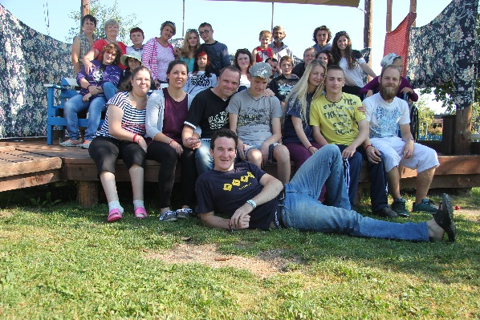

As well as the obvious benefit that Belarusian families are experiencing from the camp, the long term impact that our project is also having on our young members in Cardiff cannot be underestimated. Year after year we are providing young people with extensive experience and skills development. From the challenge of working around the clock with disabled children, to the chance to experience a different culture and language and they love it!

Some feedback from our new volunteers this year included

“It has changed my whole perspective on everything” and “The only further comment I have is simply that everyone involved is incredible.”

And from their parents

“Thank you for giving my child the opportunity of going and looking after them while over there. They are a changed person.”

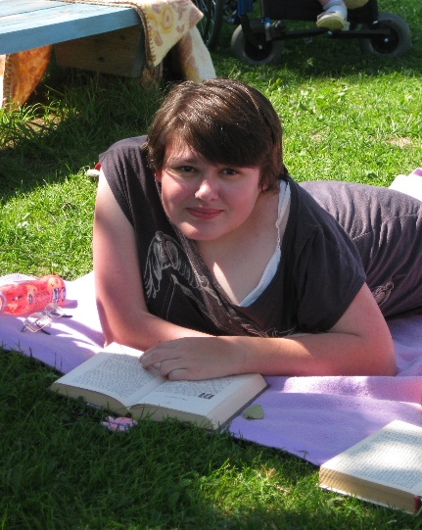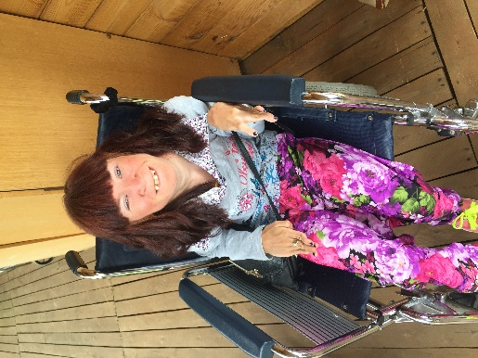Sadly, we ended the summer on a heart-breaking note. Two of our very good friends that have been coming to the camp as long as some of us have, passed away suddenly after short illnesses at the end of August. Ulya and Katya were both loved so much by all of us and we have been supporting each other with coming to terms with the thought of them not being with us each summer any more. We will miss them both very much, but are also comforted by the fact that we were able to share such great memories with them both over the years at their favourite place. Spokki nokki girls, lots of love from all of us.

More photos and videos of this summer can be found by posting this link into your browser

https://www.facebook.com/Chernobyl-Children-Cancer-Care-Cardiff-The-5Cs-134001776683923/?ref=tn_tnmn

Don’t forget you can stay in touch with us via social media- all the information is below for you.

Thank you from the bottom of my heart for your ongoing support, best wishes to you all,

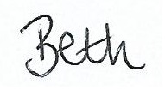

And the rest of the 5Cs family!

November 2015.

***C****hernobyl****C****hildren****C****ancer****C****are****C****ardiff*

[www.five-cs.org](http://www.five-cs.org/)  [info@five-cs.org](mailto:info@five-cs.org) +447834720757  71 Tatham Road, Llanishen, Cardiff CF14 5FD

Like us on Facebook 'Chernobyl Children Cancer Care Cardiff (The 5C's)'

Follow us on Twitter ['@FiveCsCardiff'](mailto:%27@FiveCsCardiff%27) Instagram 'the_fivecs' YouTube 'The Five C's Charity'

Donate online at [www.bt.com/mydonate](http://www.bt.com/mydonate) and search for 'The 5Cs'

Register to remember us while you shop online at <http://www.easyfundraising.org.uk/causes/5cs>

Registered Charity Number: 1077451